AIM1:-Generating descriptive statistics using summary() or describe() (R)
OUTPUT
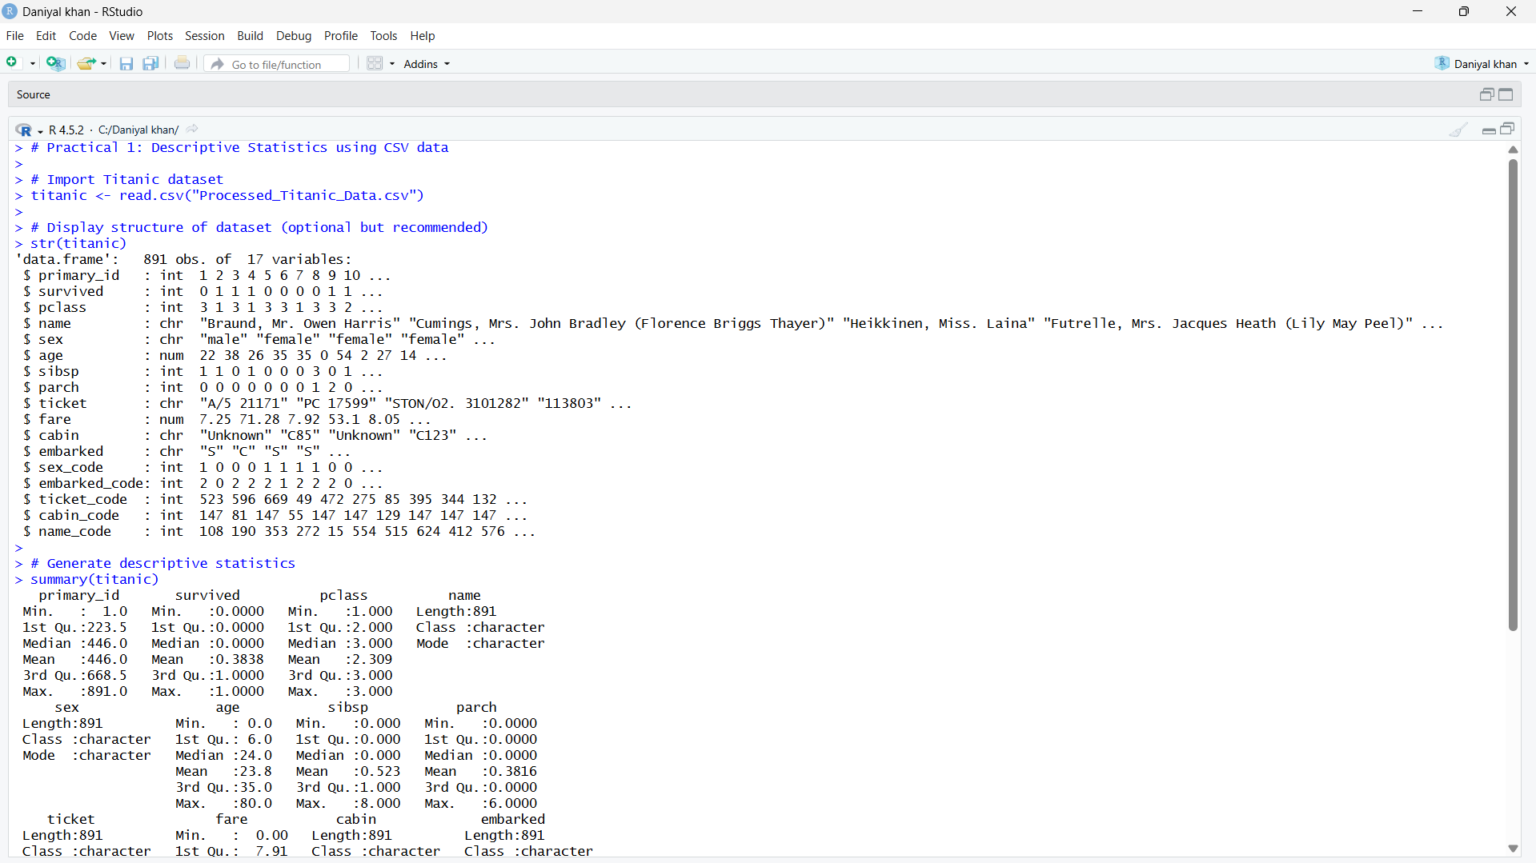
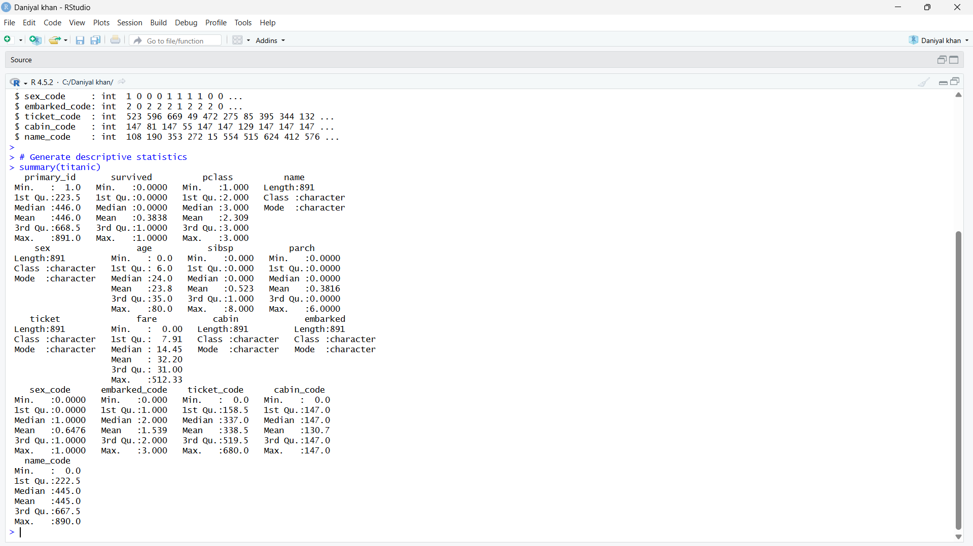
Aim2:-Generating frequency tables using table() or count() (R)
OUTPUT
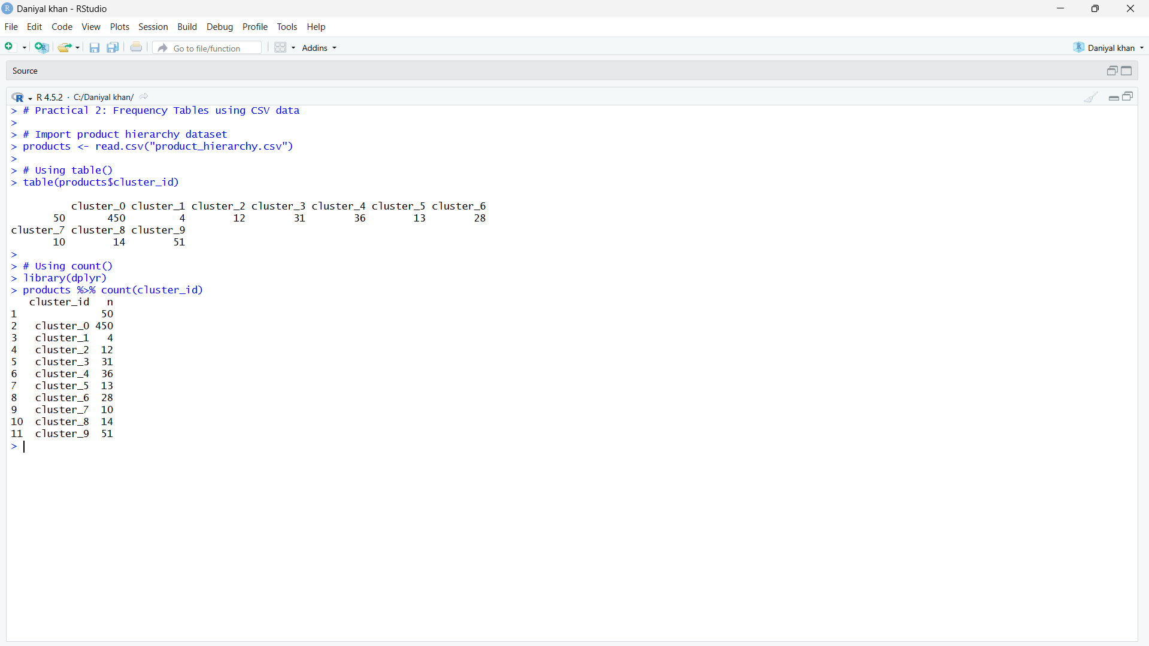
Aim3:-Creating cross-tabulations and two-way tables using table() (R)

OUTPUT
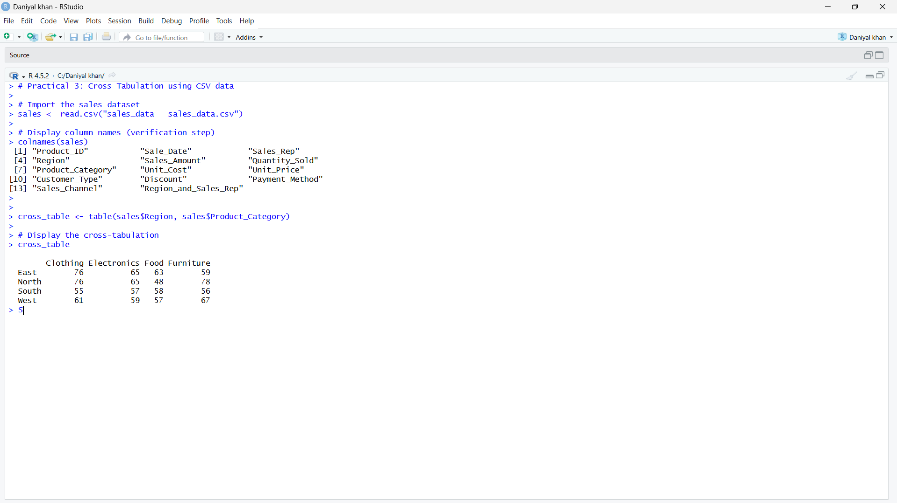
Aim4:-Performing one-sample t-tests using t.test() (R).

OUTPUT
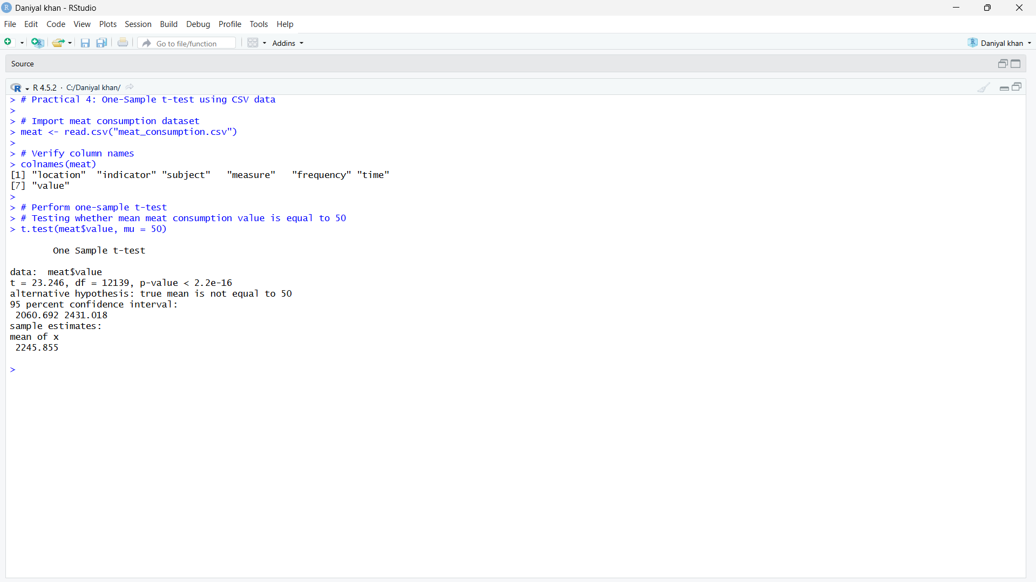
Aim5:-Performing independent two-sample t-tests using t.test() with grouping (R).

OUTPUT
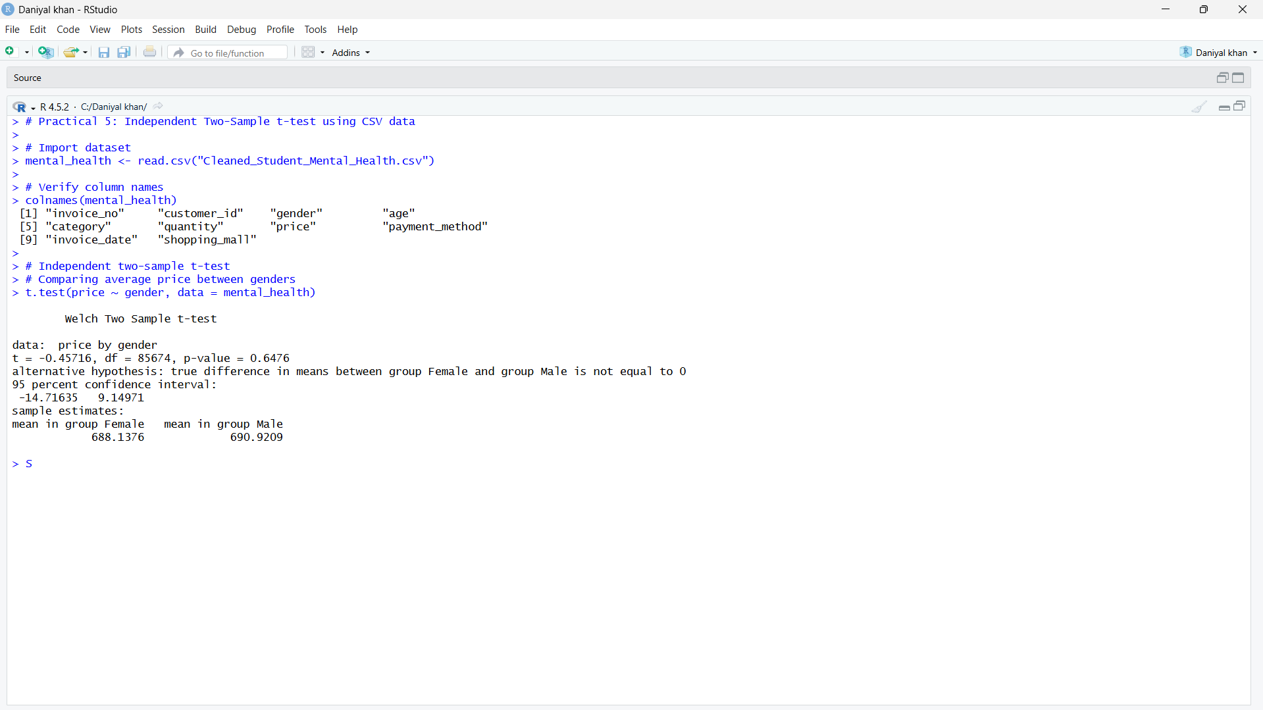
Aim6:-Performing paired t-tests using t.test(paired=TRUE) (R)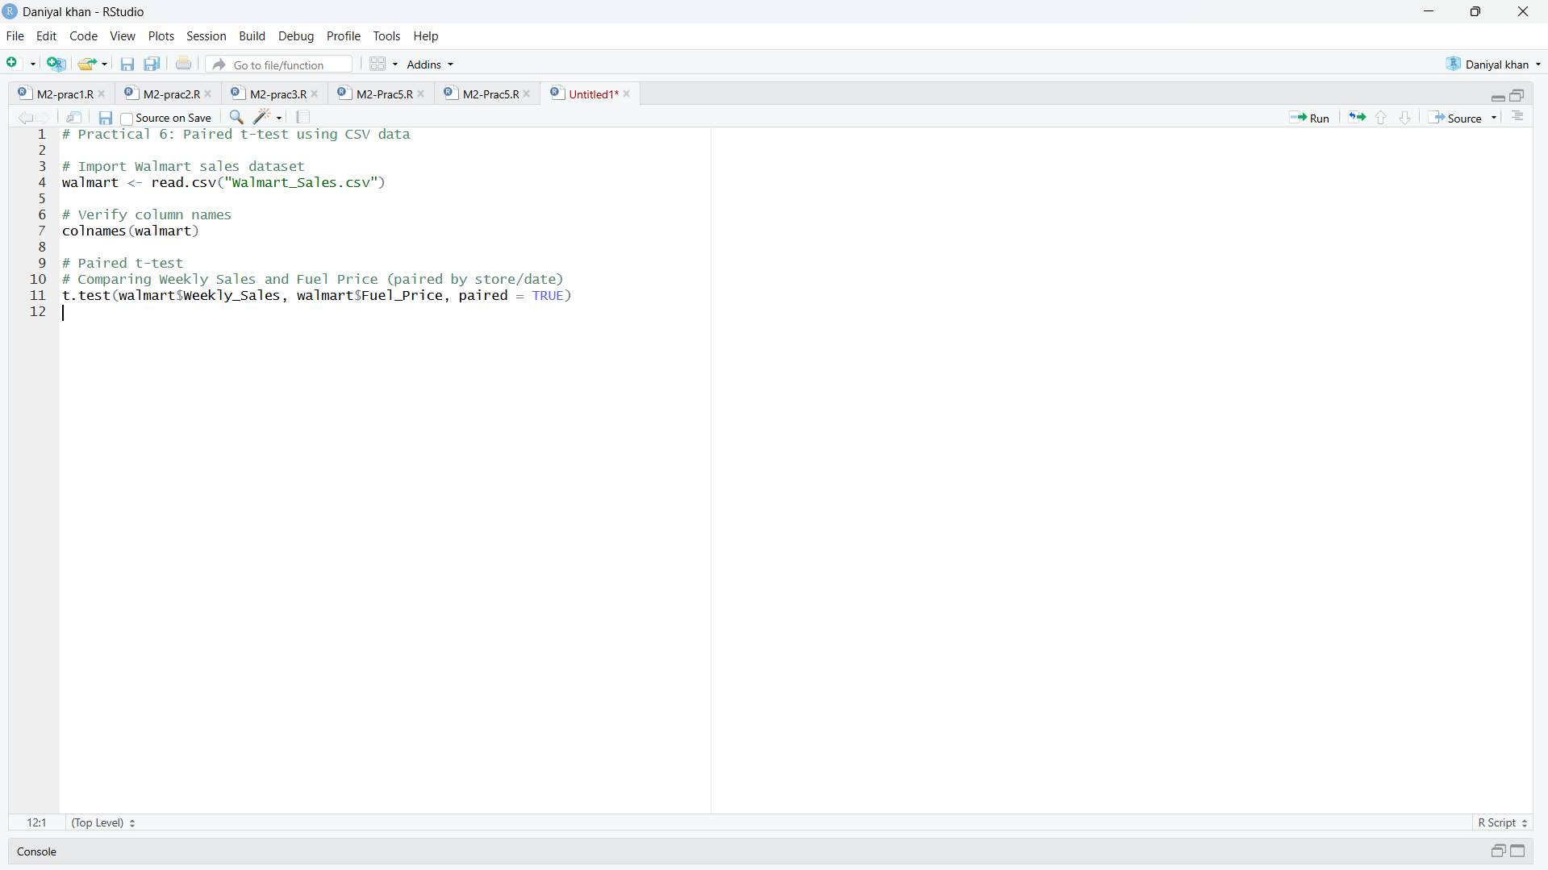
OUTPUT

